CPE301 – SPRING 2021

Design Assignment 4B

Student Name: Elmer Mejia

Student #: 5003824808

Student Email: mejiae4@unlv.nevada.edu

Primary Github address: https://github.com/cpemejia/design_assignments.git

Directory: design_assignments

1. **COMPONENTS LIST AND CONNECTION BLOCK DIAGRAM w/ PINS**

-Atmega328pb -KiCad -stepper motor

-Microchip Studio -Potentiometer - Servo Motor -ULN2003

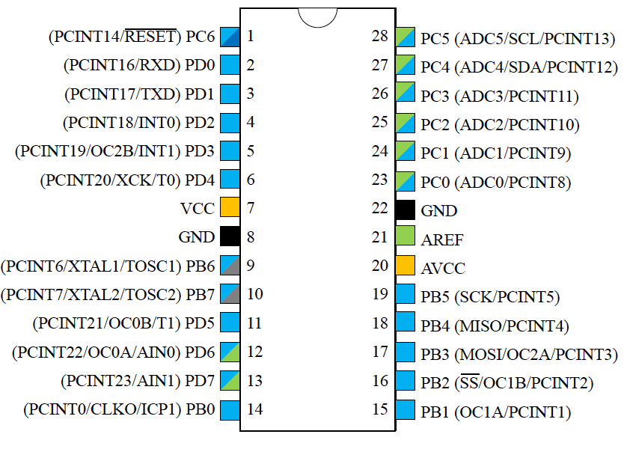



1. **INITIAL/MODIFIED/DEVELOPED CODE OF TASK 1**

/*

* DA_4B.c

*

* Created: 4/10/2021 8:21:16 PM

* Author : ElmerOMejia

*/

#define *F_CPU* 16000000UL/* Define CPU Frequency 1MHz */

#include <avr/io.h> /* Include AVR std. library file */

volatile unsigned int period;

*uint16_t* read_adc(*uint8_t* channel);

void adc_init(void);

void delay(int period);

int main(void)

{

/* Make PORTD lower pins as output */

DDRD = 0x0F;

// Set the Timer Mode to CTC

TCCR0A |= (1 << WGM01);

// Set the value that you want to count to

period = 30;

// initialize counter

TCNT0 = 0;

// set prescaler to 1024 and start the timer

TCCR0B |= (1 << CS02)|(1<<CS00);

adc_init();

while (1)

{

if (period < 30) // if MIN OCRA

period = 30;

else if (period > 230)

period = 230;

else

period = (read_adc(0)/4); // 10 bit ADC to 8 bit

/* Rotate Stepper Motor Anticlockwise with Full step sequence */

PORTD=0x09;

delay(period);

PORTD=0x03;

delay(period);

PORTD=0x06;

delay(period);

PORTD=0x0C;

delay(period);

}

}

void delay(int period){

OCR0A = period;

while( (TIFR0 & (1<<OCF0A)) ==0 );

TCNT0 = 0;

TIFR0 |=(1<<OCF0A);

}

void adc_init(void)

{

/** Setup and enable ADC **/

ADMUX = (0<<REFS1)| // Reference Selection Bits

(1<<REFS0)| // AVcc - external cap at AREF

(0<<ADLAR)| // ADC Left Adjust Result

(0<<MUX2)| // Analog Channel Selection Bits

(0<<MUX1)| // ADC0 (PC0 PIN23)

(0<<MUX0);

ADCSRA = (1<<ADEN)| // ADC ENable

(0<<ADSC)| // ADC Start Conversion

(0<<ADATE)| // ADC Auto Trigger Enable

(0<<ADIF)| // ADC Interrupt Flag

(0<<ADIE)| // ADC Interrupt Enable

(1<<ADPS2)| // ADC Prescaler Select Bits

(0<<ADPS1)|

(1<<ADPS0);

}

*uint16_t* read_adc(*uint8_t* channel){

ADMUX &= 0xF0; //Clear the older channel that was read

ADMUX |= channel; //Defines the new ADC channel to be read

ADCSRA |= (1<<ADSC); //Starts a new conversion

while(ADCSRA & (1<<ADSC)); //Wait until the conversion is done

return ADCW; //Returns the ADC value of the chosen channel

}

1. **INITIAL/MODIFIED/DEVELOPED CODE OF TASK 2**

/*

* servo.c

*

* Created: 4/12/2021 8:52:20 PM

* Author : ElmerOMejia

*/

#define *F_CPU* 8000000UL /* Define CPU Frequency e.g. here its 8MHz */

#include <avr/io.h> /* Include AVR std. library file */

#include <stdio.h> /* Include std. library file */

#include <util/delay.h> /* Include Delay header file */

void adc_init(void);

*uint16_t* read_adc(*uint8_t* channel);

int main(void){

adc_init(); /* Initialize ADC */

DDRB |= (1<<PB1); /* Make OC1A pin as output */

TCNT1 = 0; /* Set timer1 count zero */

ICR1 = 2499; /* Set TOP count for timer1 in ICR1 register */

TCCR1A = (1<<WGM11)|(1<<COM1A1);

/* Set Fast PWM, TOP in ICR1, Clear OC1A on compare match, clk/64 */

TCCR1B = (1<<WGM12)|(1<<WGM13)|(1<<CS10)|(1<<CS11);

while(1)

{

OCR1A = 65 + (read_adc(0)/4.35); /* Read ADC channel 0 and make count in between 65-300 i.e. 0.5-2.4 mSec duty cycle variation */

}

}

void adc_init(void)

{

/** Setup and enable ADC **/

ADMUX = (0<<REFS1)| // Reference Selection Bits

(1<<REFS0)| // AVcc - external cap at AREF

(0<<ADLAR)| // ADC Left Adjust Result

(0<<MUX2)| // Analog Channel Selection Bits

(0<<MUX1)| // ADC0 (PC0 PIN23)

(0<<MUX0);

ADCSRA = (1<<ADEN)| // ADC ENable

(0<<ADSC)| // ADC Start Conversion

(0<<ADATE)| // ADC Auto Trigger Enable

(0<<ADIF)| // ADC Interrupt Flag

(0<<ADIE)| // ADC Interrupt Enable

(1<<ADPS2)| // ADC Prescaler Select Bits

(0<<ADPS1)|

(1<<ADPS0);

}

*uint16_t* read_adc(*uint8_t* channel){

ADMUX &= 0xF0; //Clear the older channel that was read

ADMUX |= channel; //Defines the new ADC channel to be read

ADCSRA |= (1<<ADSC); //Starts a new conversion

while(ADCSRA & (1<<ADSC)); //Wait until the conversion is done

return ADCW; //Returns the ADC value of the chosen channel

}

1. **SCREENSHOTS OF EACH TASK OUTPUT (ATMEL STUDIO OUTPUT)**

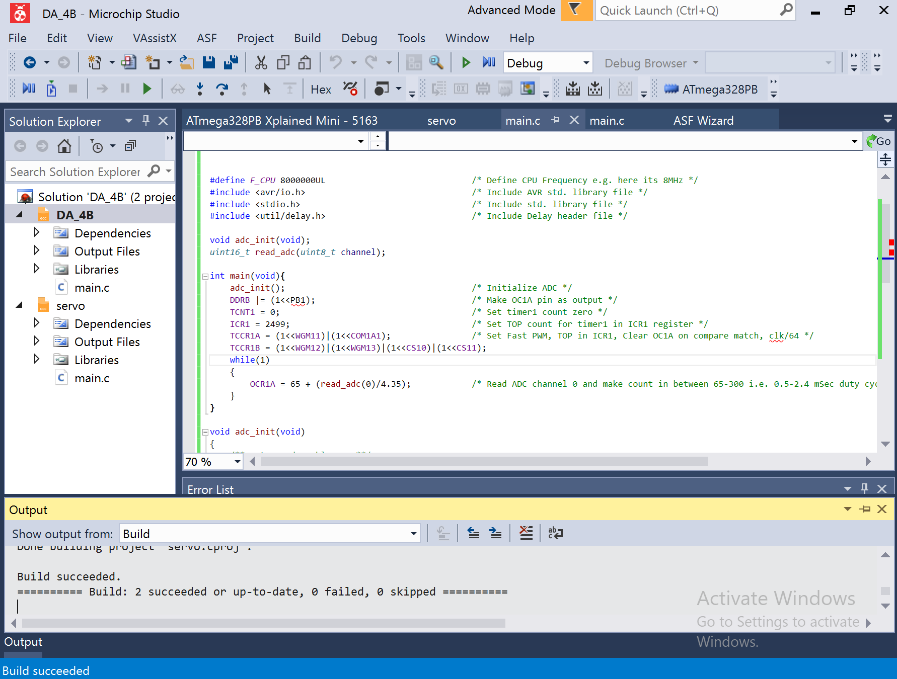

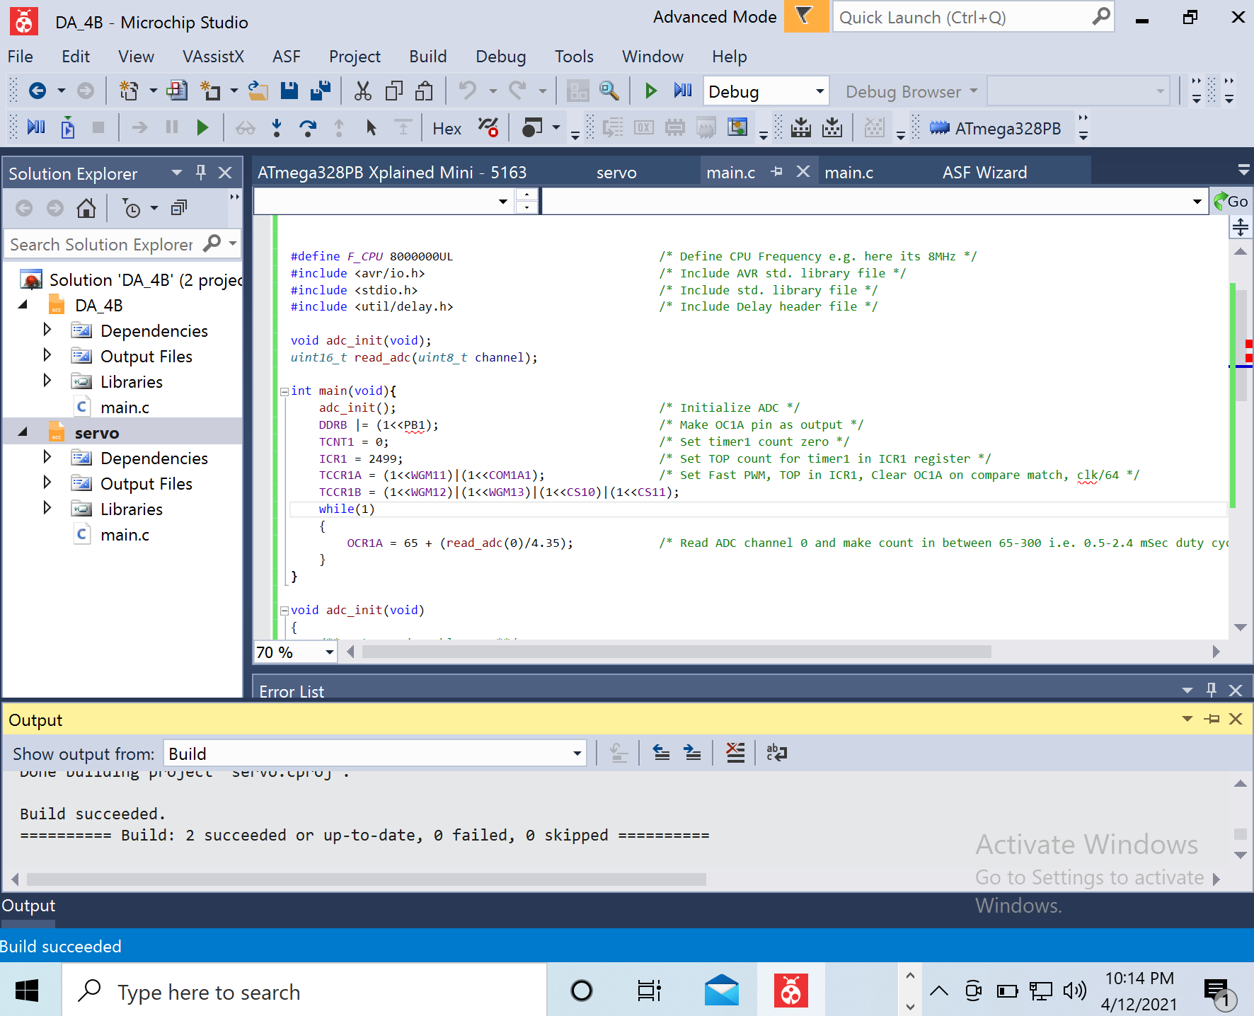

1. **SCREENSHOT OF EACH DEMO (BOARD SETUP)**

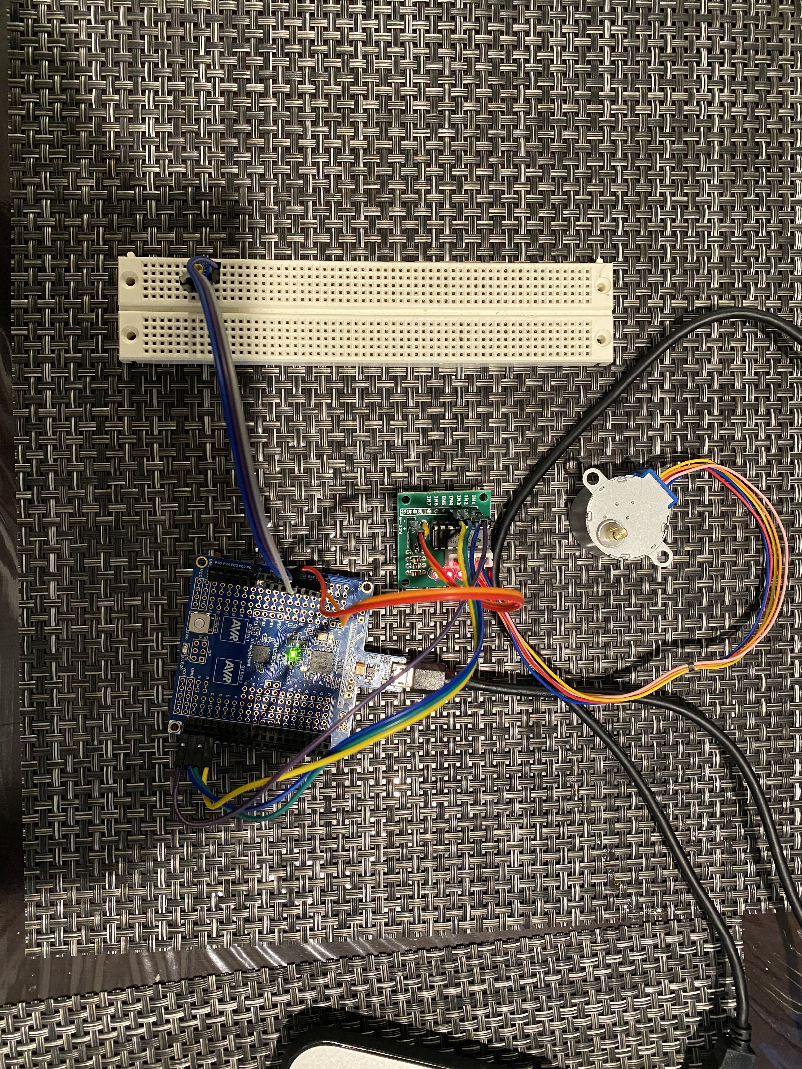

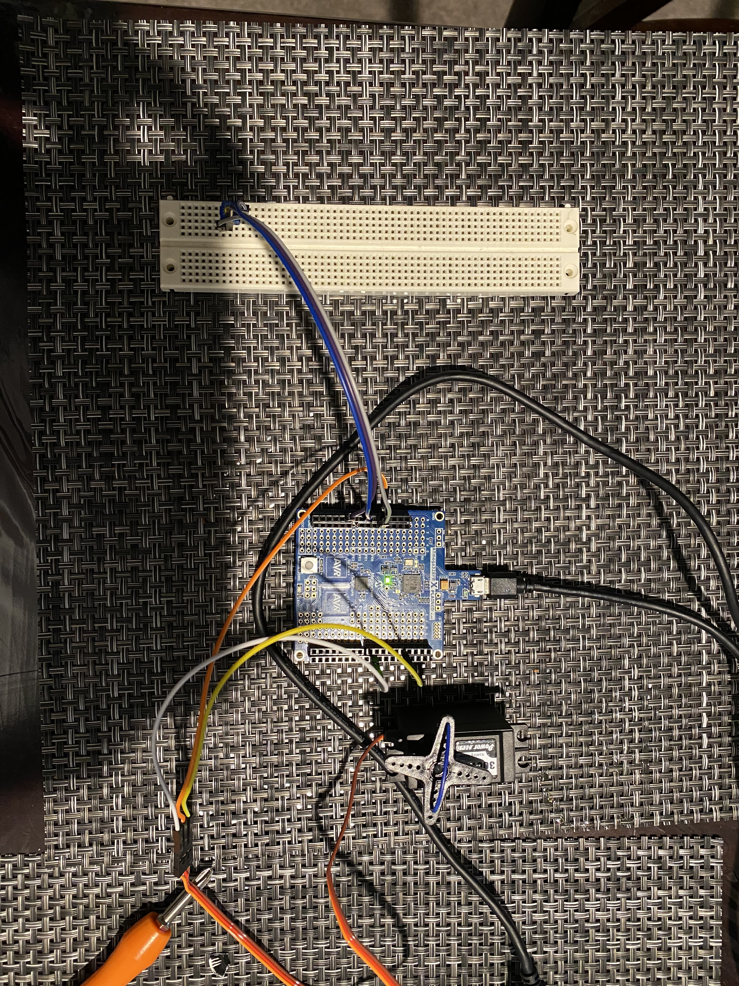

1. **VIDEO LINKS OF EACH DEMO**

[Design_assignments](https://youtube.com/playlist?list=PL6PbL2NpuYCKbUNnRQzdehoDwvBhUNAA1)

1. **GITHUB LINK OF THIS DA**

[DA_git](https://github.com/cpemejia/design_assignments.git)

**Student Academic Misconduct Policy**

<http://studentconduct.unlv.edu/misconduct/policy.html>

“This assignment submission is my own, original work”.

Elmer Mejia